MATHS Assignment

**Anuvind MP AM.EN.U4AIE22010**

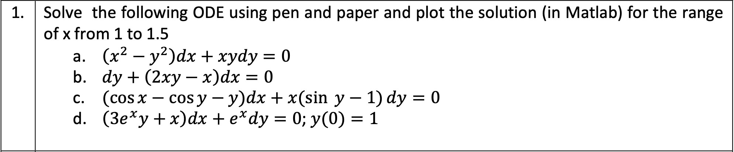

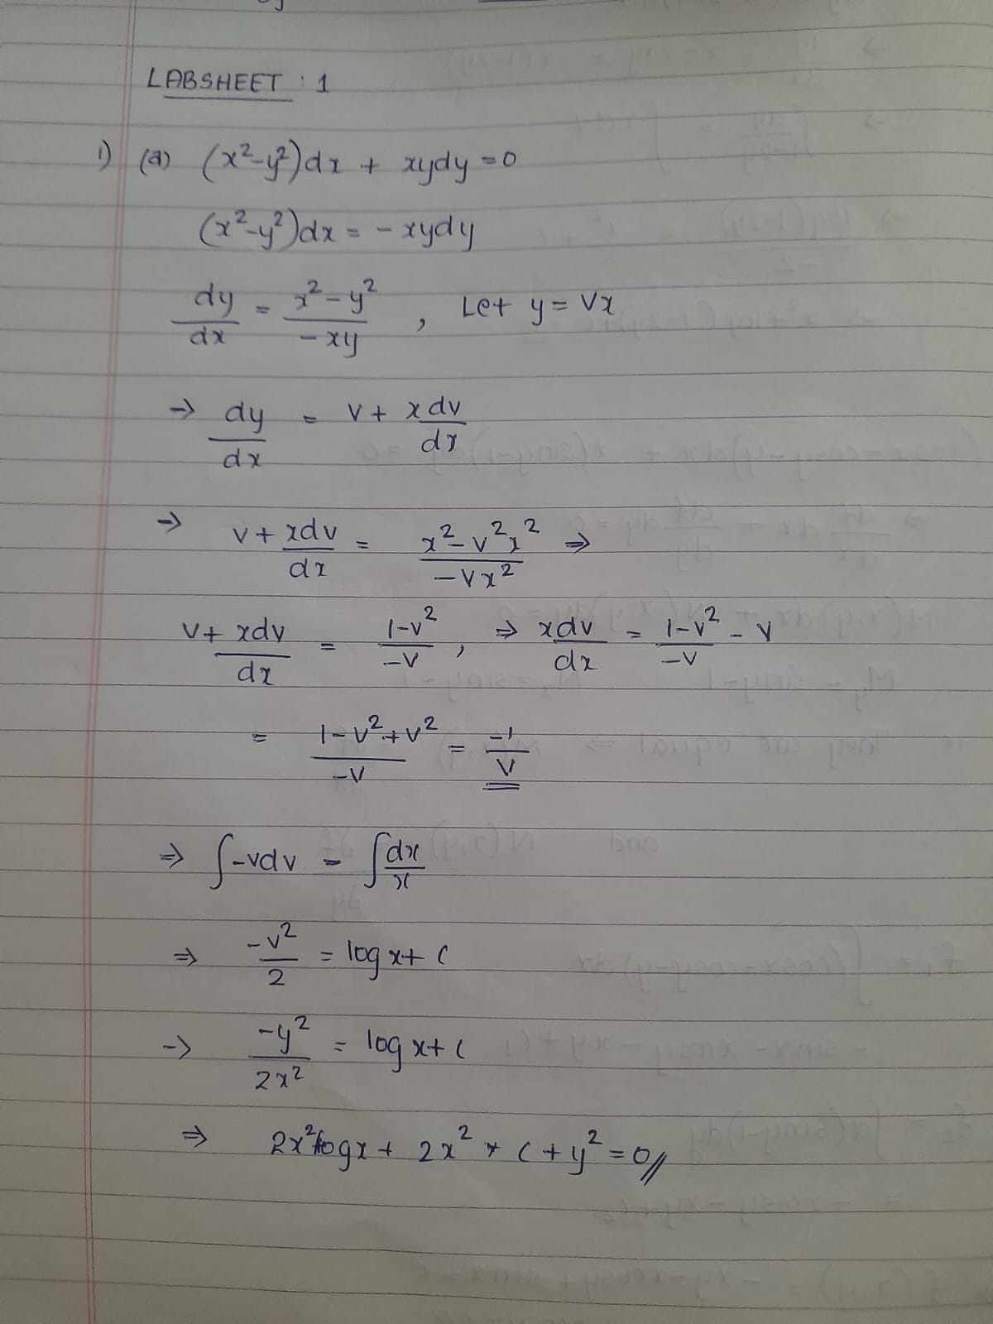

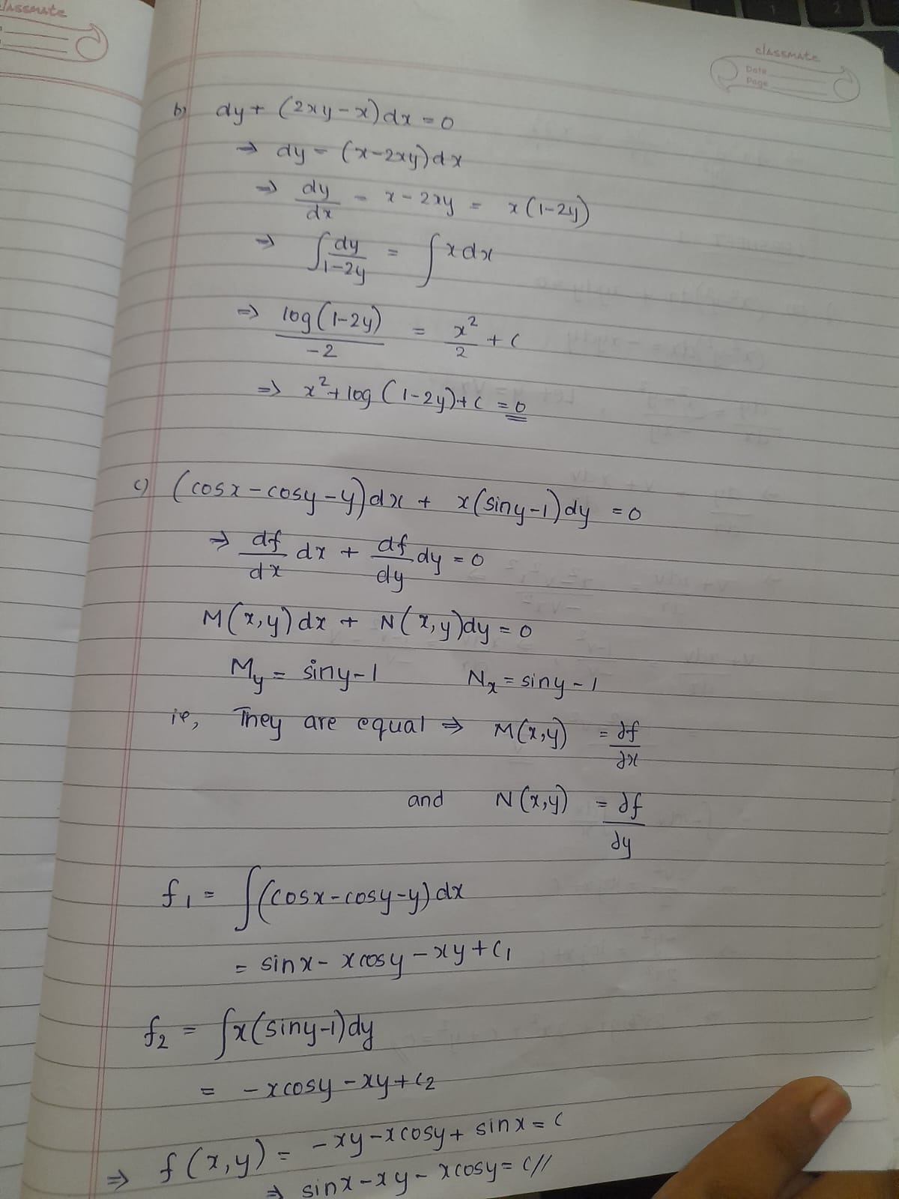

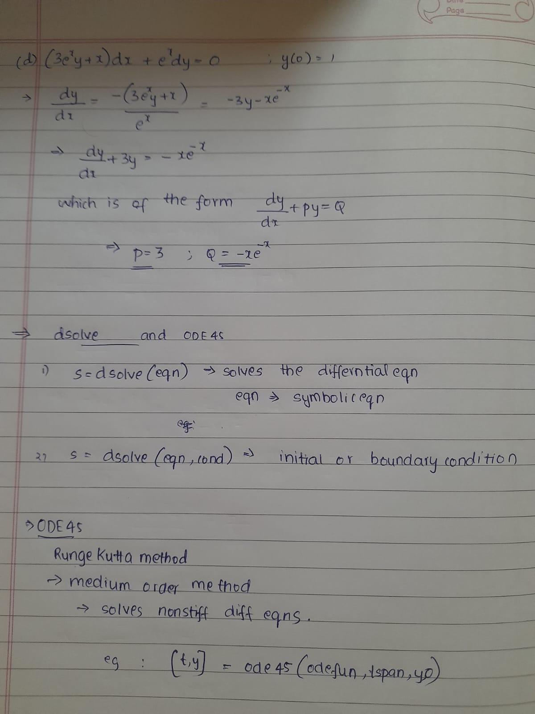

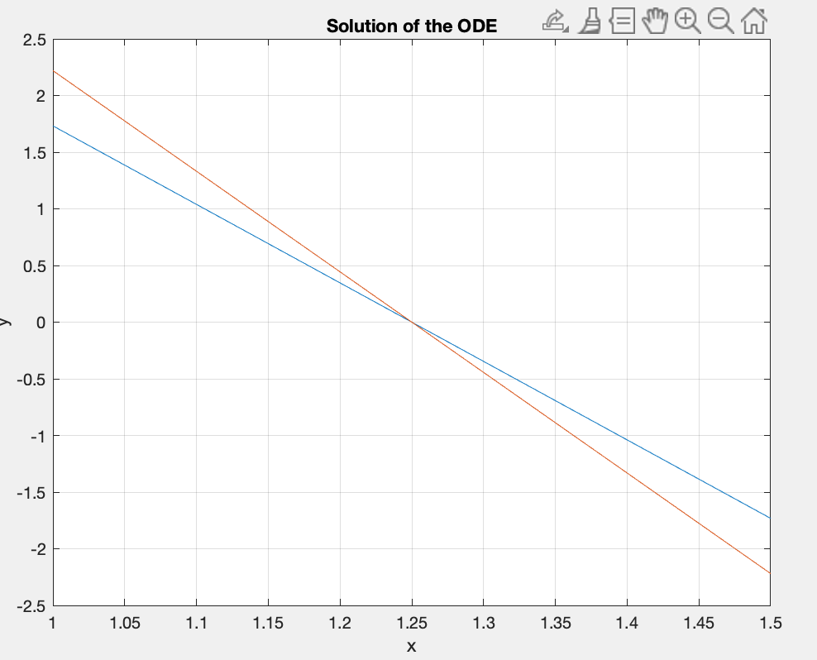

1. **CODE**

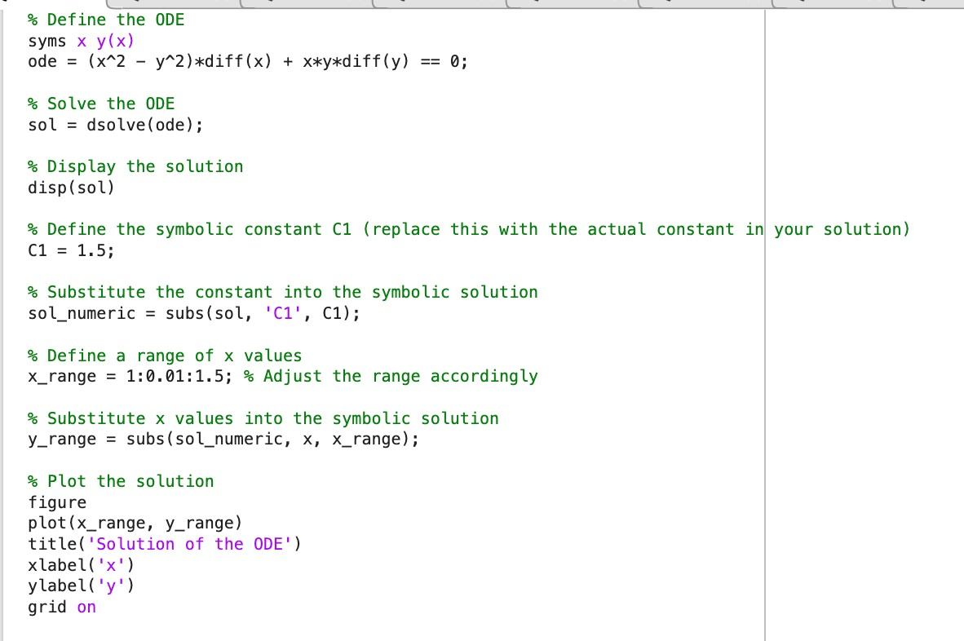

**Result**

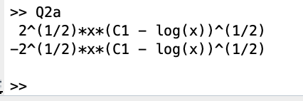

1. **CODE**

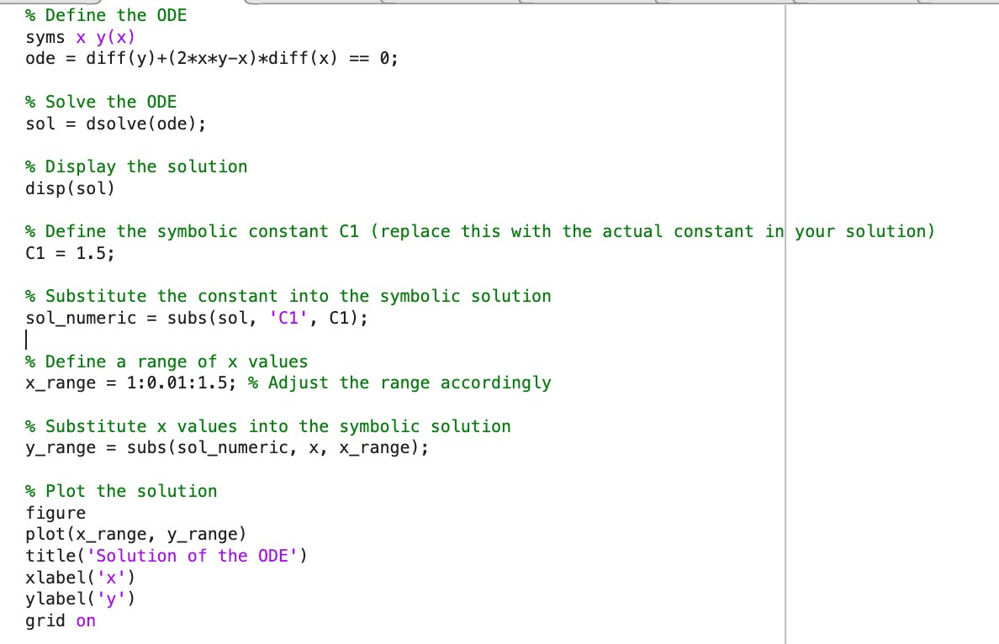

**Result**

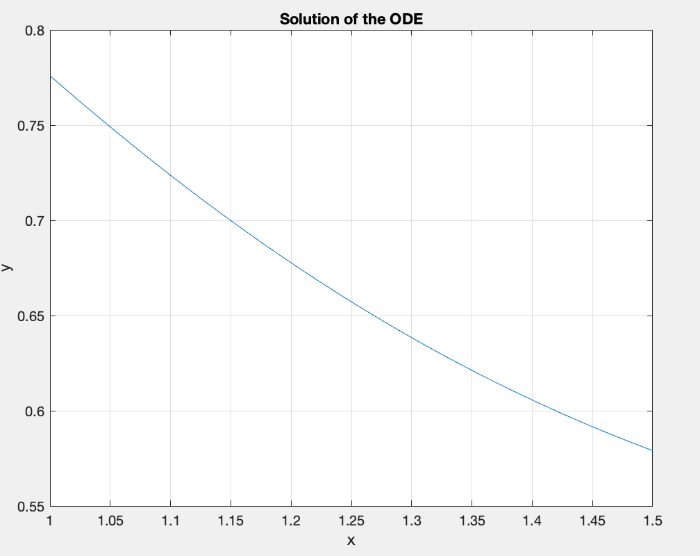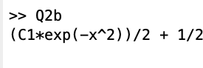

1. **CODE**

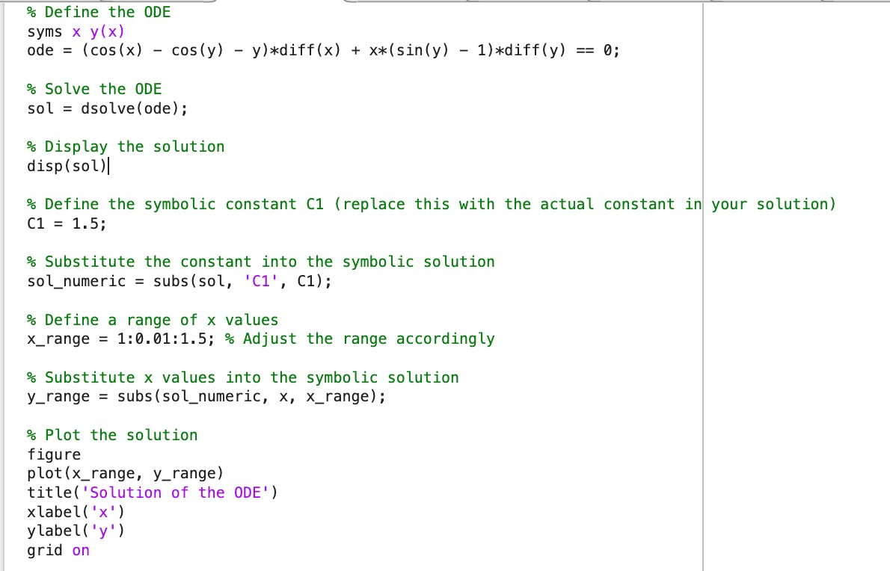

**Result**

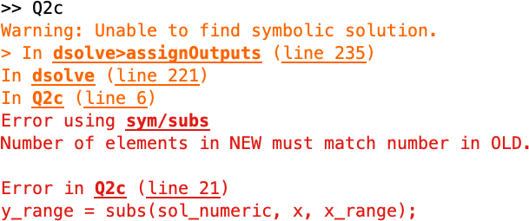

1. **CODE**

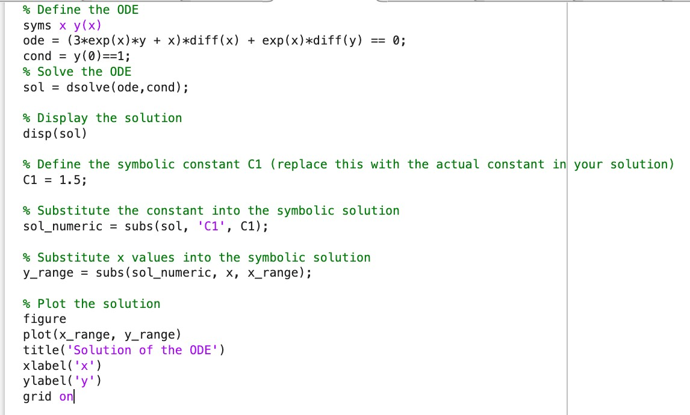

**Result**

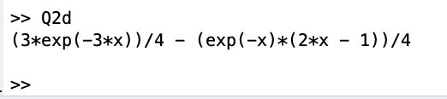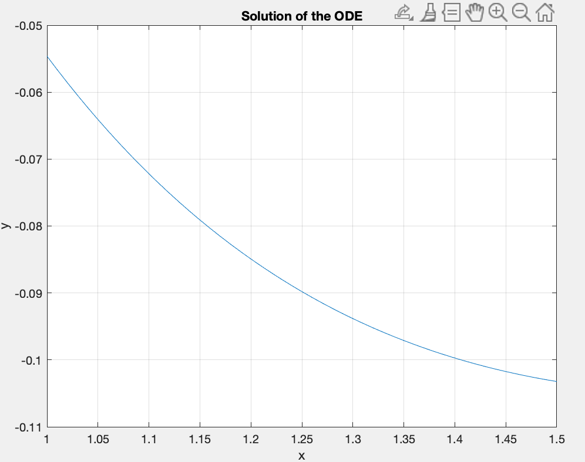

**OBSERVATION**

If the dsolve function is unable to find a symbolic solution for the given ordinary differential equation (ODE) here question ‘c’, it could be due to the complexity of the equation or the absence of explicit symbolic solutions. This commonly occurs when dealing with nonlinear or highly intricate ODEs.

When faced with such a situation, it becomes necessary to resort to numerical methods for solving the ODE. Numerical methods, like the ode45 function in MATLAB, can provide approximate solutions by discretizing the problem and iteratively solving it over a specified range.

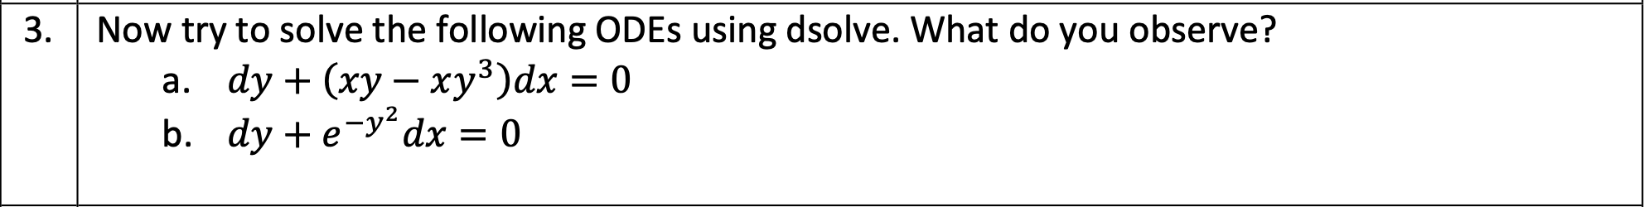

1. **CODE**

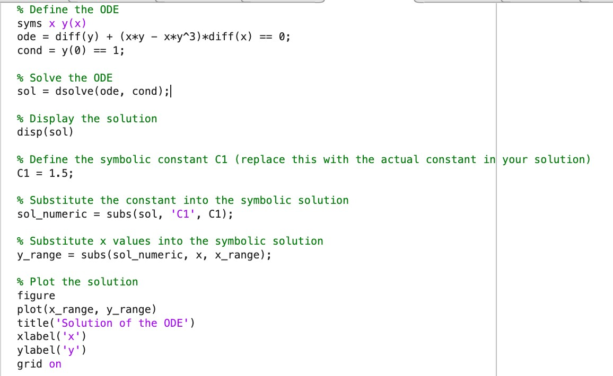

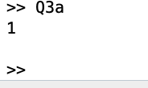**Result**

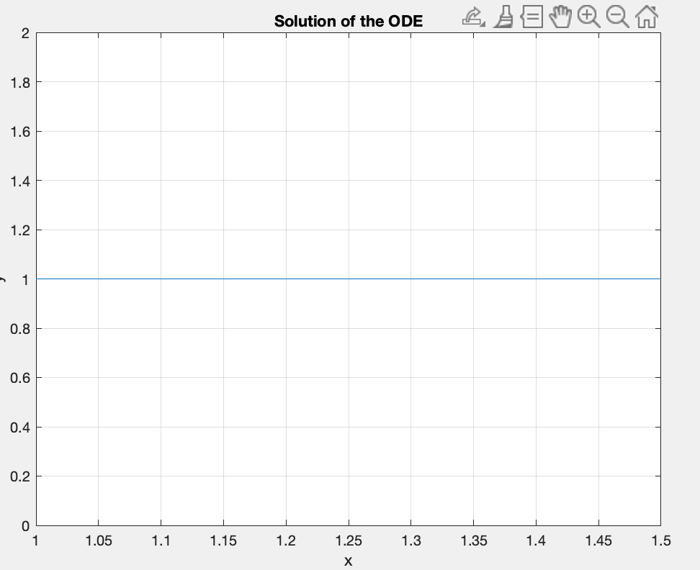

1. **CODE**

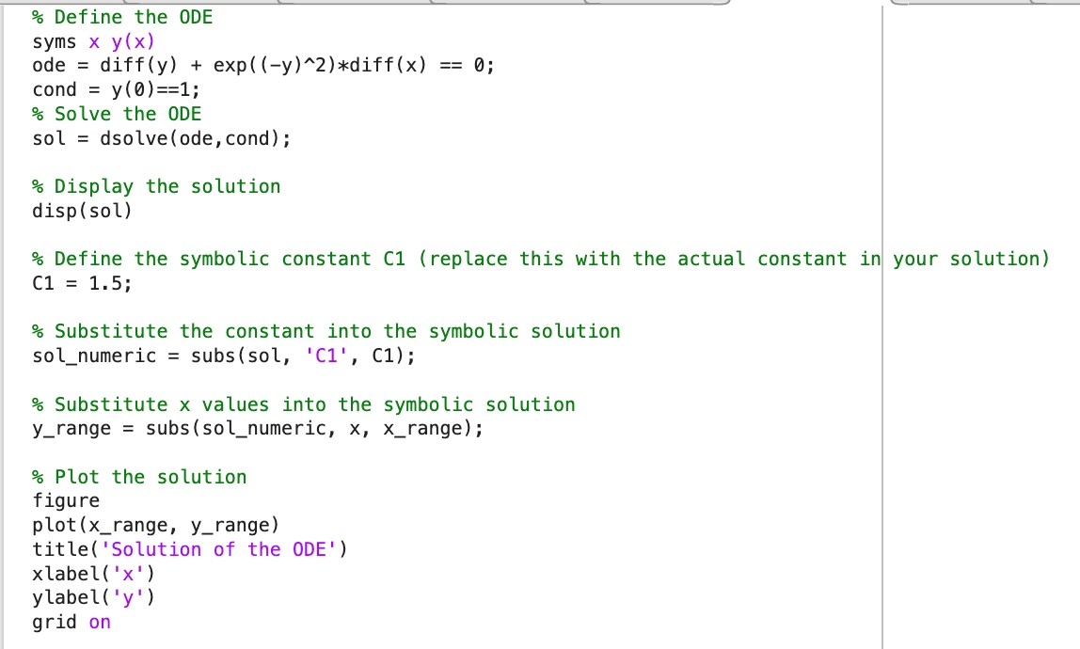

**Result**

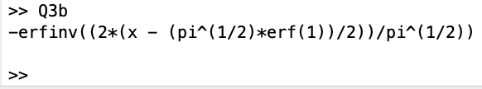

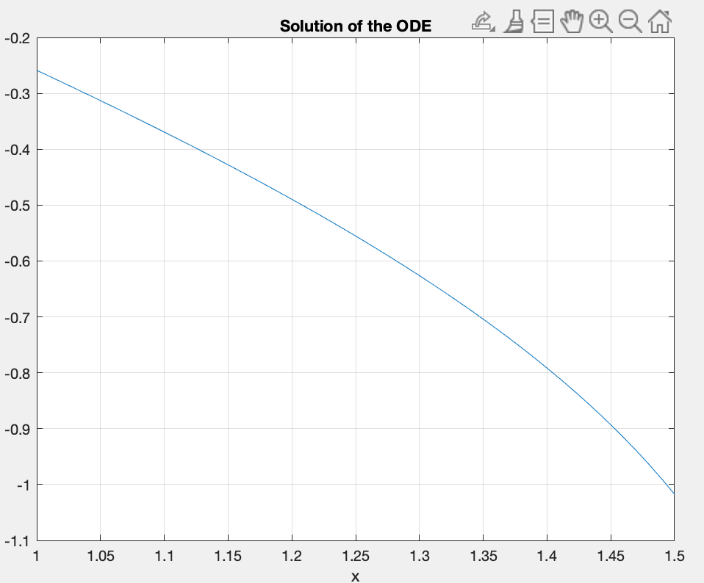

1. **CODE**

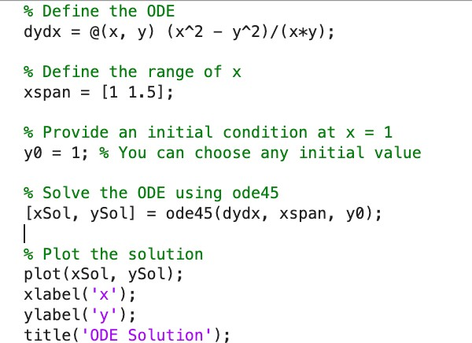

**Result**

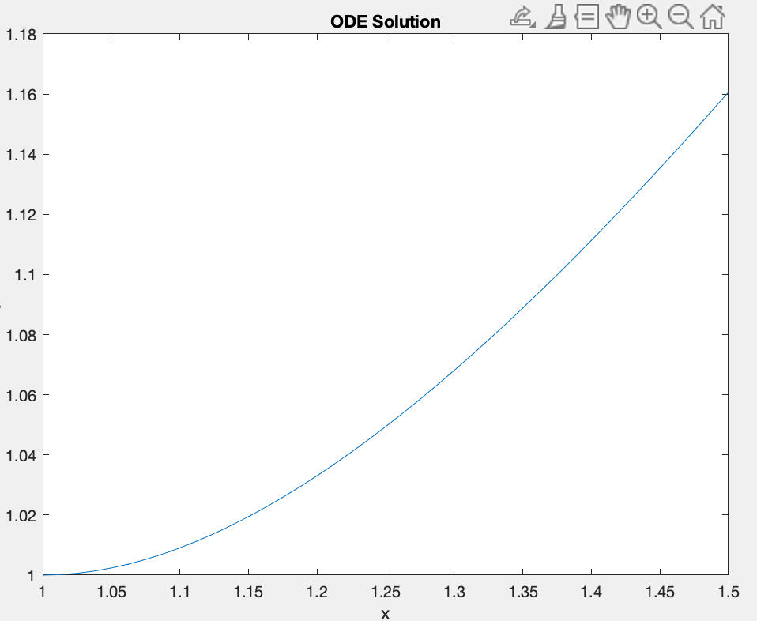

1. **CODE**

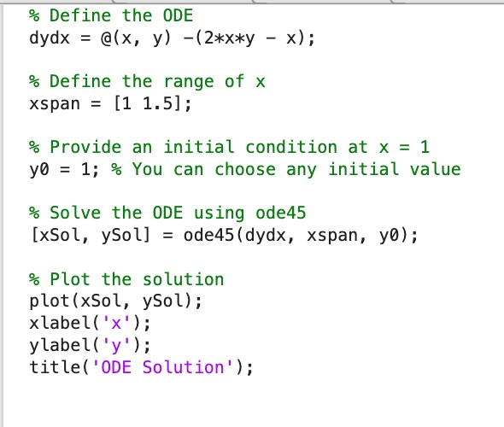

**Result**

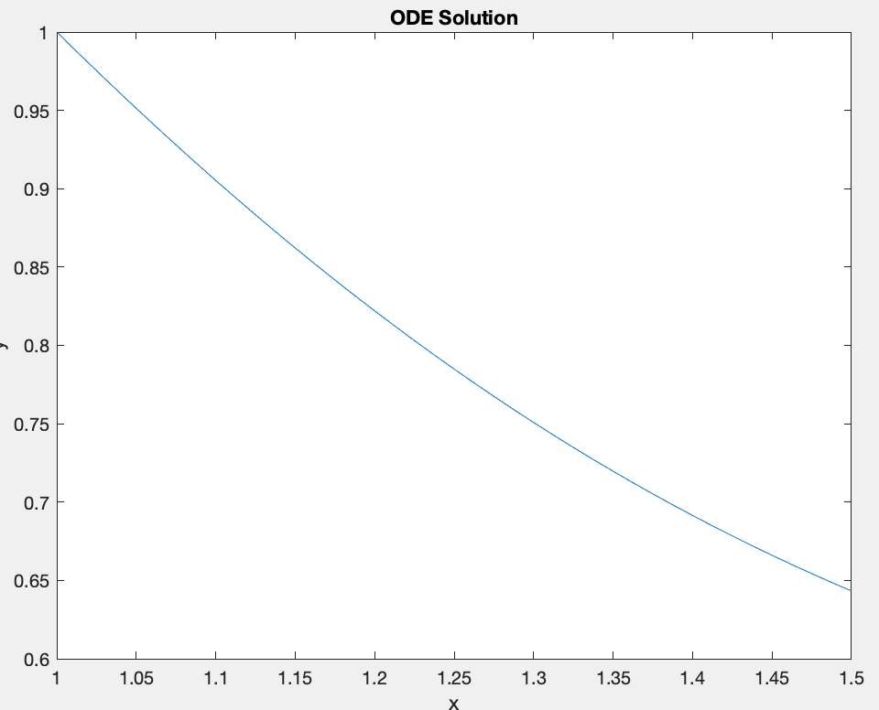

1. **CODE**

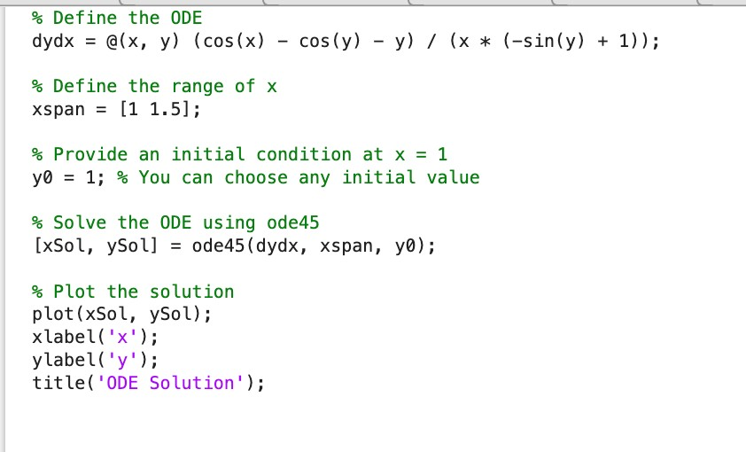

**Result**

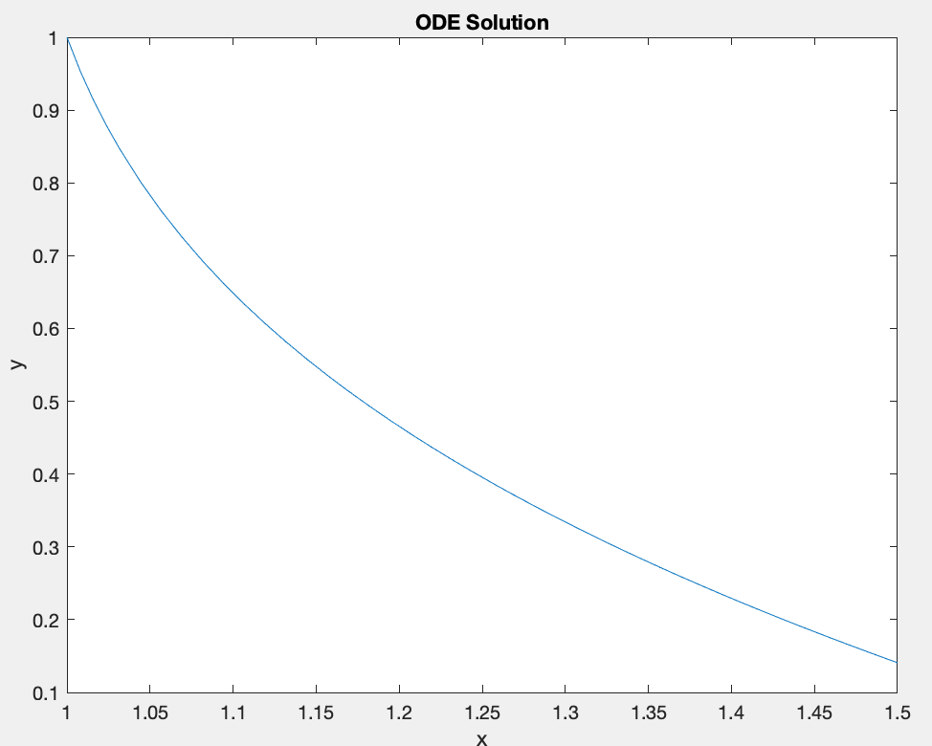

1. **CODE**

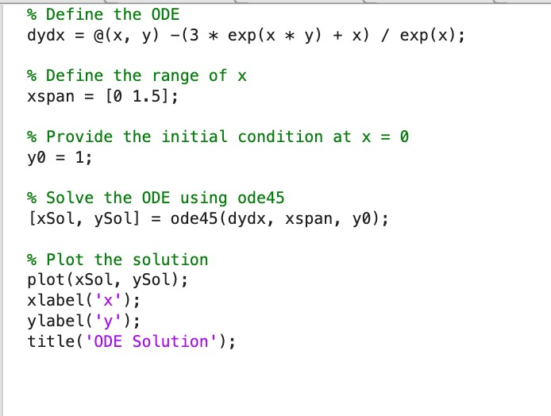

**Result**

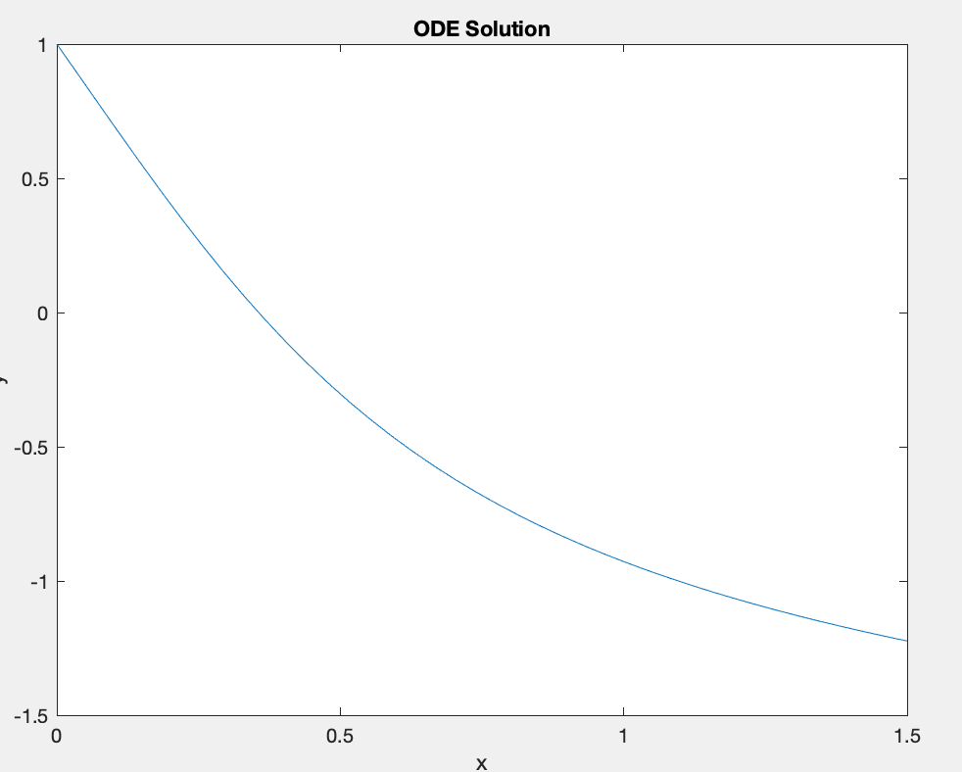

**e)**

**CODE**

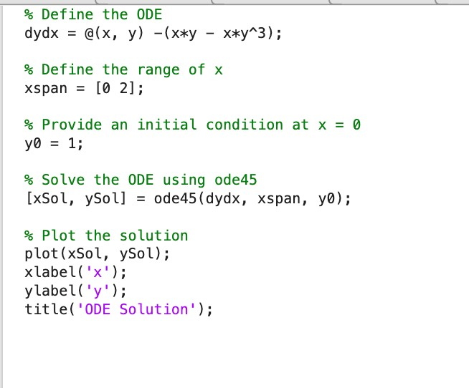

**Result**

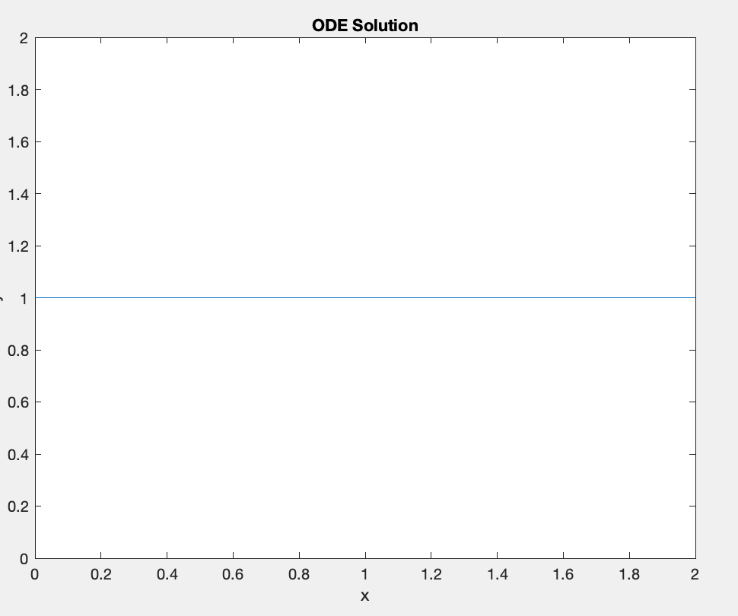

**f) CODE**

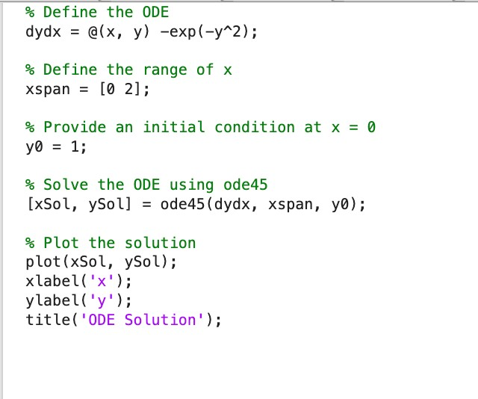

**Result**

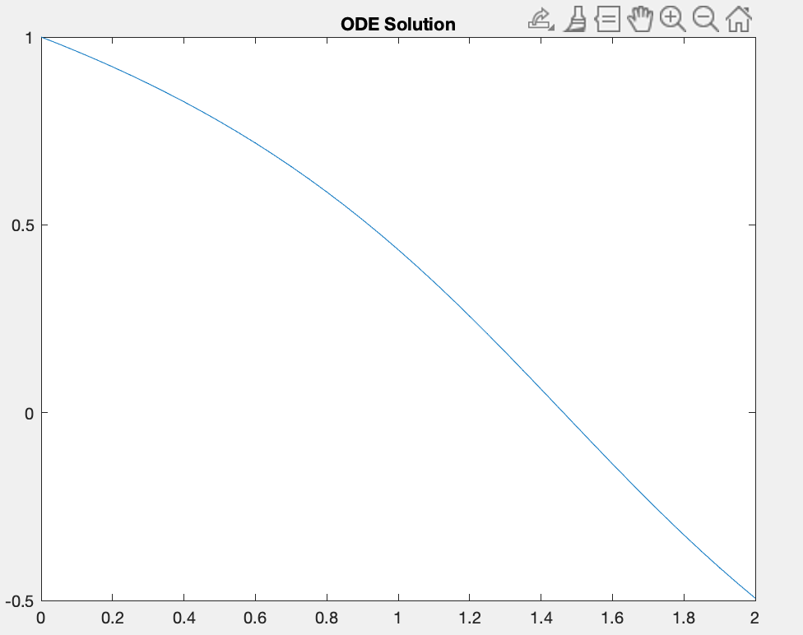

**Euler Method**

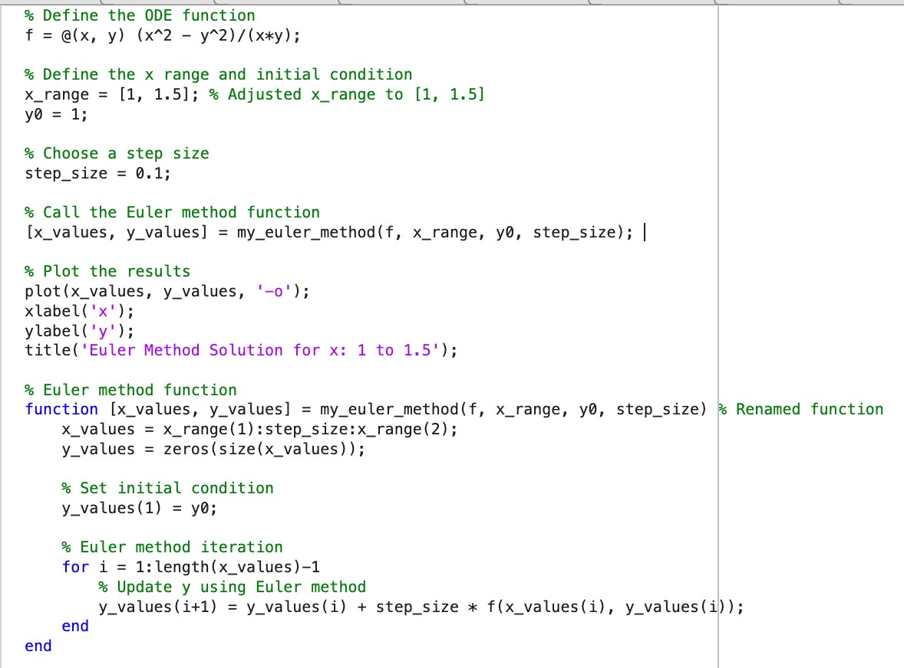

**Result**

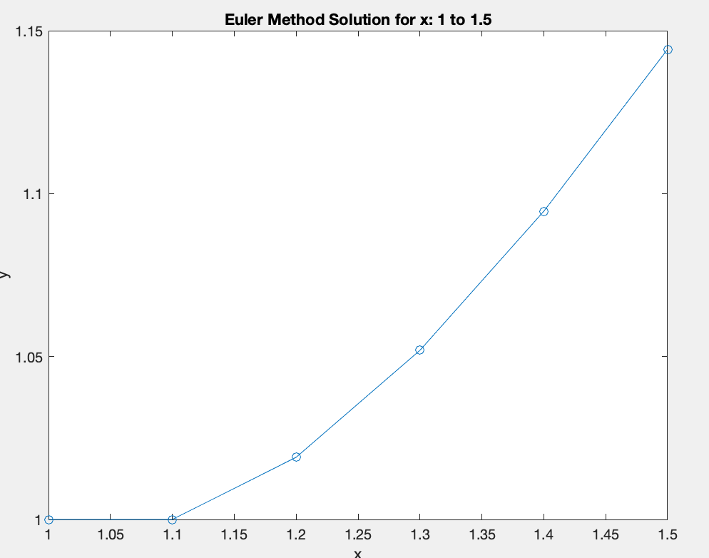

**RK Method**

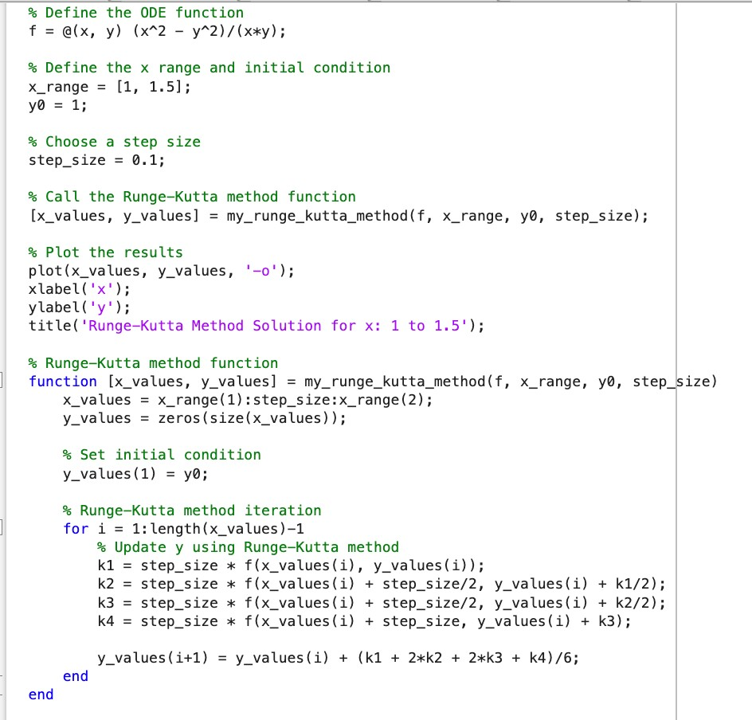

**Result**

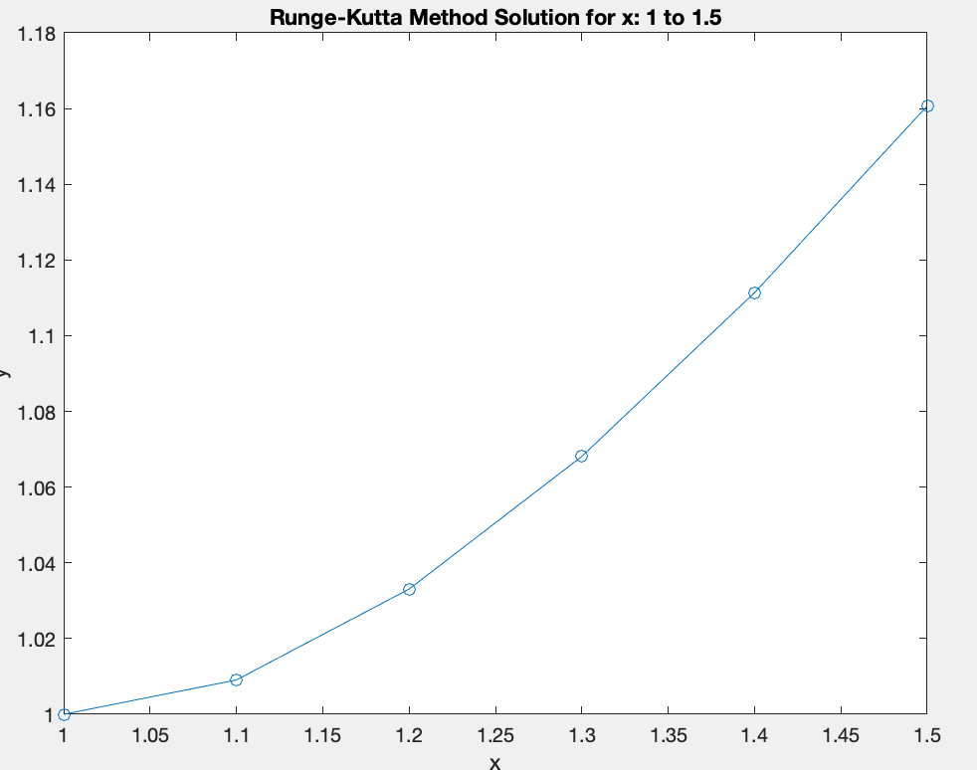

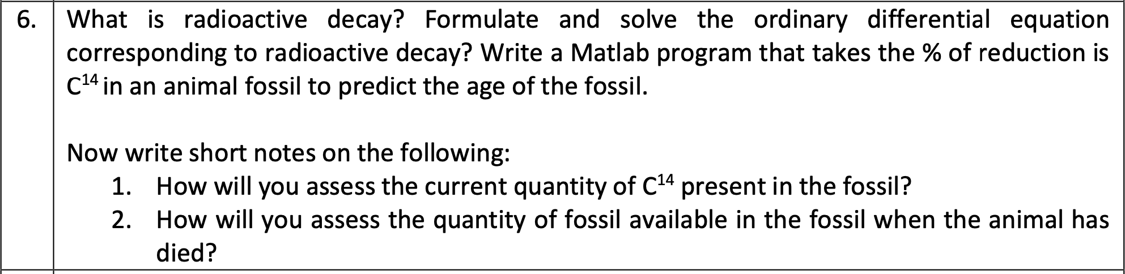

**CODE**

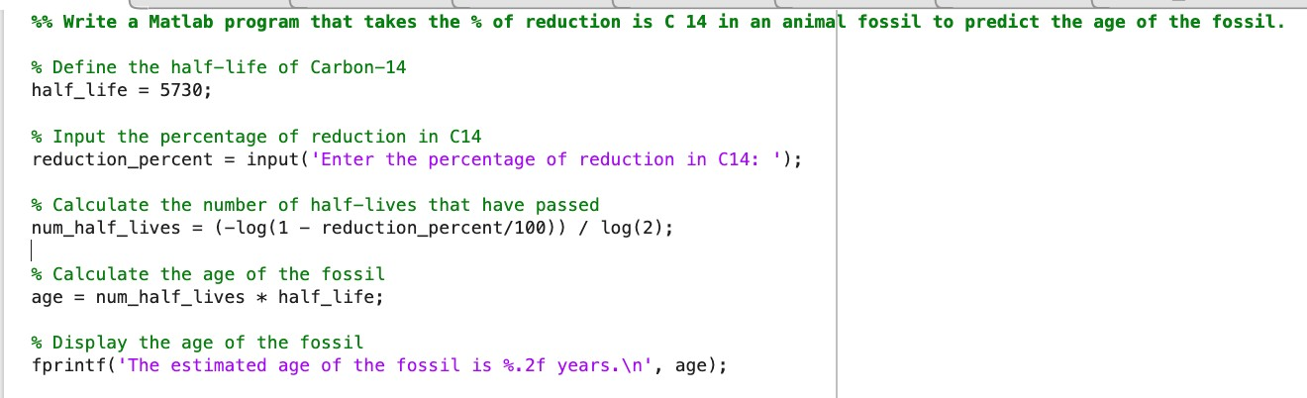

**Result**

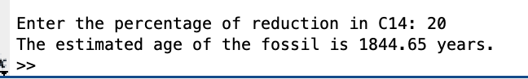

write a short note on How will you assess the current quantity of C14 present in the fossil?

**Ans:**

Fossils reveal their age through C14, a radioactive timer. Sensitive machines directly measure its remaining whisper, or stable isotopes hint at its past abundance. But beware, contamination and environment can muddle the message. Experts decipher these clues, unlocking ancient secrets one decay at a time.

How will you assess the quantity of fossil available in the fossil when the animal has died?

**Ans**:

Assessing fossil quantity involves field excavation, estimating volume, utilizing advanced imaging like photogrammetry, conducting laboratory analysis, and employing remote sensing techniques such as LiDAR. These methods help determine the extent, density, and composition of fossil material, aiding in understanding ancient ecosystems and population dynamics.